Test Driven Development

Article: 5 steps of test-driven development
Source: https://developer.ibm.com/articles/5-steps-of-test-driven-development/?mhsrc=ibmsearch_a&mhq=testing

- What is test-driven development?

- The process of crafting a failing test, and then implementing the function/feature to produce a successful test. This is different from how people traditionally wrote code. They would first develop the function/feature and then create the test. Reversing this process enables us to produce cleaner and well-throughout code.
- Unit Test: test that covers a small portion of logic. This is a test that should be deterministic and should not rely on external dependencies.

- Five Steps of TDD:
- Read, Understand, and process the feature or bug request.
- Translate the requirement by writing a unit test. If you have hot reloading set up, the unit test will run and fail as no code is implemented yet.
- Write and implement the code that fulfills the requirement. Run all tests and they should pass, if not repeat this step.
- Clean up your code by refactoring.
- Rinse, lather and repeat.

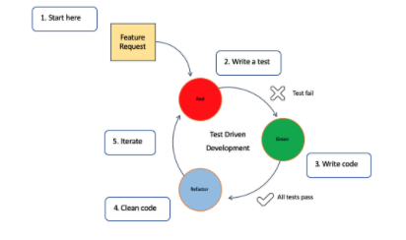

  - This workflow is sometimes called Red-Green-Refactoring, which comes from the status of the tests within the cycle.

- Test-driven development and CI/CD

- The unit tests that come out of TDD are also an integral part of the continuous integration/continuous delivery process.
- Continuous integration is a development practice that requires developers to integrate code into a shared repository several times a day. Each check-in is then verified by an automated build, allowing teams to detect problems early. By integrating regularly, you can detect errors quickly, and locate them more easily.

